Due date: at the end of your lab period

Note: all commands in this lab will be used during quizzes and exams.

Mark 10

Purpose:

Create Linux clone, create and remove MBR partitions from a Linux Virtual Hard Disk

Procedure:

Important: - in this lab, we will be using the Linux **clone** in case you mess things up.

Note: Make sure you answer the questions and have snapshots of your work.

**Install open-VM-tools:**

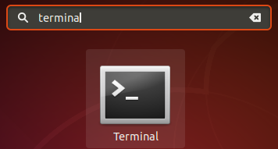

VM-tools: allows you to resize the display size and it makes VM runs smoothly.

Go to the command line (Terminal) by pressing Ctrl - Alt **+** (plus sign)

At the prompt type: sudo apt-get install open-vm-tools (lower case) press enter

At the end, the terminal would ask you Do you want to continue, press Y

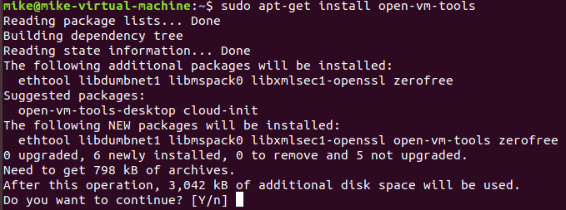

**Create a clone of your Linux os**

1- shut down your VM. Go to the command line (terminal) and type:

sudo shutdown -h now press enter (all lower case) (exam)

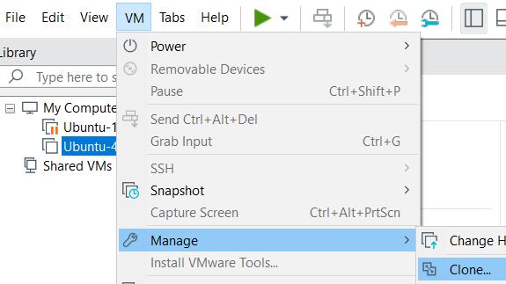

2-In your VM screen select **VM** => Manage => **Clone**

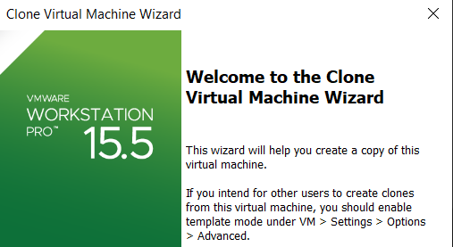

Click Next

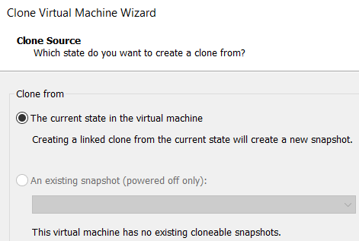

Click Next

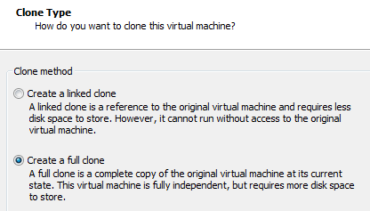

3-After going through the default setting the **clone type** screen

comes up, select **Create a full clone** click **Next**

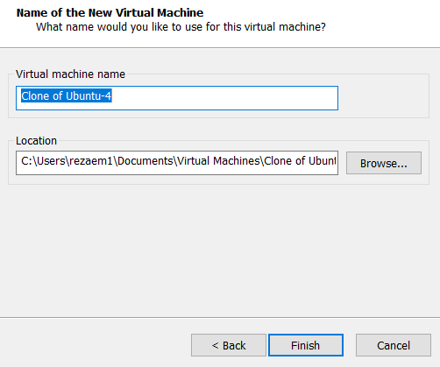

Click Next

4- Then **finish**

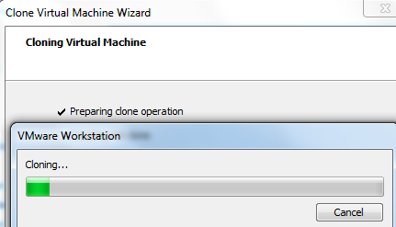

5- cloning process take a few minutes

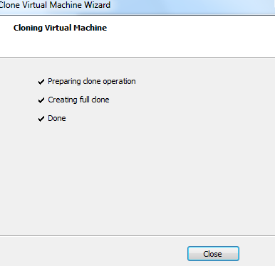

6-click **Close**

**Adding a new virtual hard drive to an existing VM**

Select your **Linux clone** from your VM **library** and add a new virtual hard disk. Double click on your **VM Hard Disk**; this brings up the **Virtual Machine Settings** as shown in Figure 1 below.

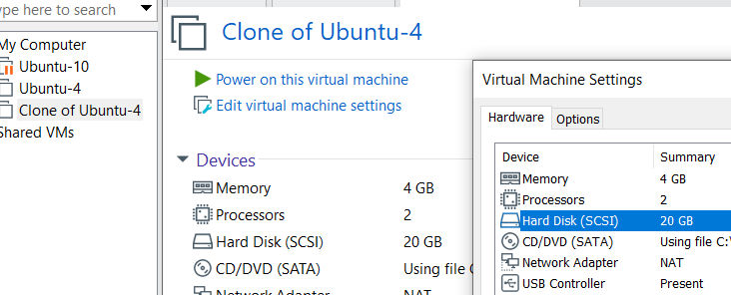

Figure 1. Double Click on the Hard Disk (SCSI)

Select the **Hard Disk,**  click on the **Add** button; see Figure 2, located on the bottom of the screen on the left-hand side.

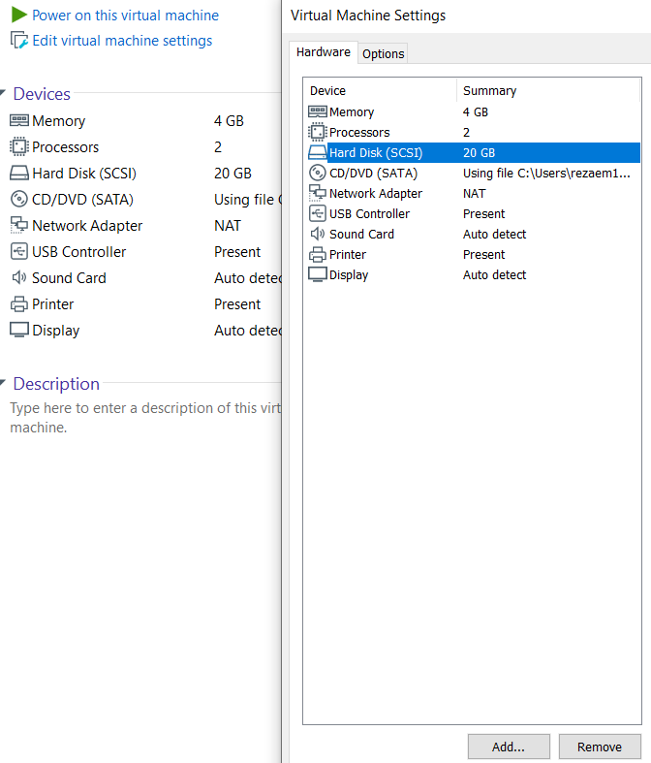

Add

Figure 2. Add Button

This brings up the **Add Hardware** Wizard, see Figure 3. Select the Hard **Disk** and click the **Next** button.

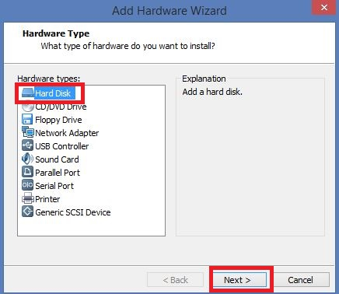

Figure 3. Add Hardware Wizard.

Accept the default options from the **Select a Disk Type** Menu and click the **Next** button.

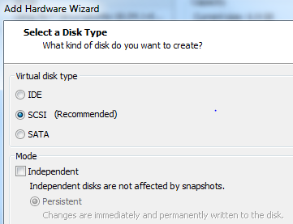

Click **Next** (exam)

Select the **Create** a new virtual disk radio button and click the **Next** button.

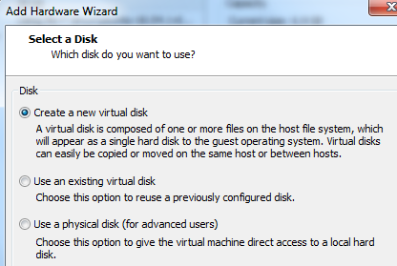

Click **Next**

Select a **Maximum** disk size of **4 GB** and select the **Store virtual disk as a single file**, as shown in Figure 5 below.

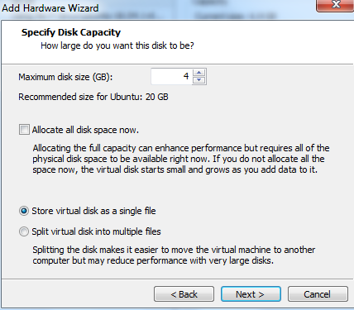

Figure 5.Hard Disk Size.

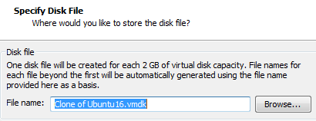

Click the **Next** button and accept the

default name for the disk file. Click **Finish.**

You will now be taken to the **Virtual Machine Settings** menu and you should see a **4 GB** drive displayed. Click the **OK** button.

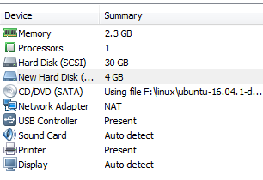

Power on the **Virtual Machine (Clone Ubuntu)** and log on to your Linux VM.

***Exercise #1: Viewing existing partitions***

Go to your **clone** VM and then **Terminal**

Switch to **root user** with the command: **sudo -s – root** press **enter**

When prompted enter your **root** password and hit **enter**, remember nothing will show on the screen when you type your **password.** (**Exam**)

**Note**: the prompt user has been changed from ~$ to **~#**  (sudo prompt) (Exam)

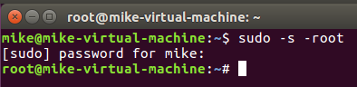

To create partitions, we will be using **fdisk (Exam)**

The syntax of the **fdisk** command is: **fdisk */dev/device_name***

* Type **fdisk /dev/sda (be carful there is a space between fdisk and /dev)**
* Within the **fdisk** utility type **m** for a list of menu options at the "Command (**m** for help):" prompt

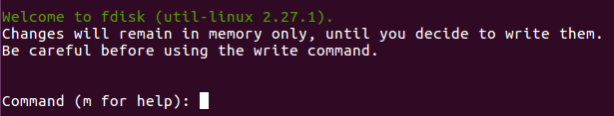

**Questions**

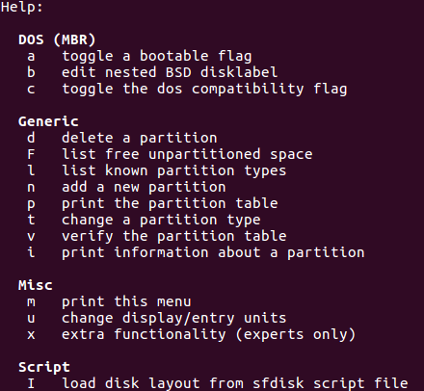

* Record the (one-character) **fdisk** command to:(Red)
  + display/list all partitions: F
  + create a new partition:  N
  + delete a partition: D
  + list partition types: L
  + change a partition's system identification: U
  + save changes made to the partition table: W
  + exit **fdisk** without saving: Q
* Select the option that lists the **partition types** and record the **system id** of the following types:

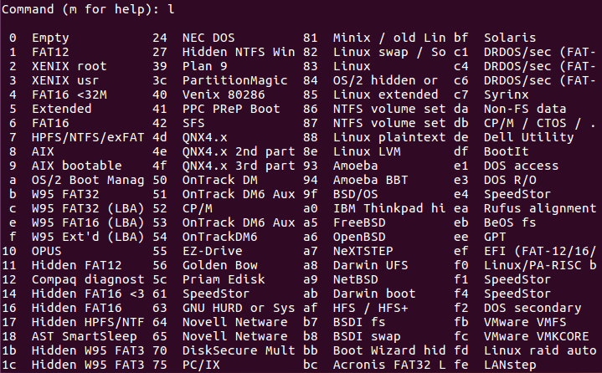

* + "Linux ": 83
  + "Linux swap": 82

***Exercise #2: Creating partitions***

Start the **Terminal** and switch to **root** user with the command: **sudo -s – root**

When prompted enter your **root** password and hit **enter**, remember nothing will show on the screen when you type your password. (**Exam**)

1. Switch to the new hard drive by typing: **fdisk /dev/sdb**

A warning may appear – ignore it.

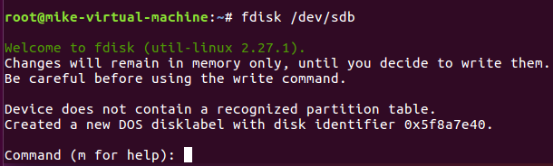

1. Create a new **primary** partition by selecting **n**, then select **p** for primary partition and select the number one,**1,** for the partition number. Accept the default for the **first sector** by pressing the **Enter** key. The size of the primary partition is 500MB**, so** enter **+500M** and press **ente**r

Note: make sure you follow the down figure exactly

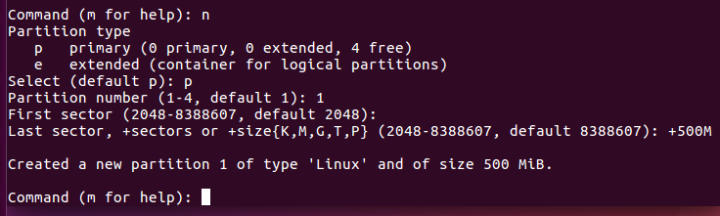

1. Press the **p** key to display the primary partition you just created in the partition table.

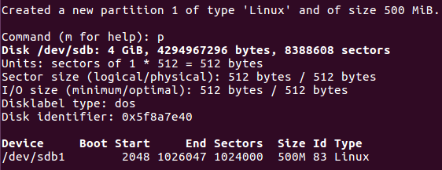

1. Create another **primary** partition by selecting the **n** key, then select **p** for the primary partition and select the number **2** for the partition number. Accept the default for the first sector by pressing the **Enter** key. The size of the second primary partition is 200MB**,** so enter **+200M** and press the **enter key.**
2. Press the **p** key to **display** the two primary partitions you just created in the partition table.

Create an **extended** partition to host **three logical** drives - keep in mind that you must make it large enough to encapsulate the logical drive described below. HINT: There will be problems if you try to make it exactly **1000MB.** So you will need to experiment; try entering **1005MB** instead:

1. To create an **extended** partition press the **n** key, then select the **e** key for an **extended** partition. Select the number **3** for the partition number. Accept the default for the first sector by pressing the **Enter** key. The size of the extended partition should be **1000MB** but you will get an error**,** so enter+**1005M** and press the **enter key.**
2. Press the **p** key to **display** the **two primary** partitions and one **extended** partition you just created in the partition table.
3. To create a **logical** drive in the **extended** partition press the **n** key, then select the **l** key for a logical drive. A logical drive is created and is numbered **5**. Accept the default for the first sector by pressing the **Enter** key. The size of the logical drive should be 500MB, so enter **+500M** and press the **enter key.**
4. Press the **p** key to display the **two primary** partitions, the **extended** partition and the **logical** drive you just created.
5. To create another logical drive in the extended partition press the **n** key, then select the **l** key for a logical drive. A logical drive is created and is numbered **6**. Accept the default for the first sector by pressing the **Enter** key. The size of the logical drive should be 300MB, so enter **+300M** and press the **enter key.**
6. Press the **p** key to display the **two primary** partitions, the **extended** partition, and the **two logical** drive you just created.
7. To create another logical drive in the extended partition press the **n** key, then select the **l** key for a logical drive. A logical drive is created and is numbered **7**. Accept the default for the first sector by pressing the **Enter** key. The size of the logical drive should be 200MB so enter **+200M** and press the **enter key. You may get an error here – value out of range depending on the size you made your extended partition. If you get an error make your partition size smaller say 197M. if you did not get any error, then continue.**

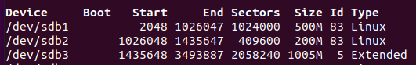

Example of partitions

1. Press the **p** key to display the two primary partitions, the extended partition, and the three logical drive you just created. Record the output by taking a **screenshot** using the Windows **Snipping tool** (snapshot) and pasting it here:

**Snapshot here -1**

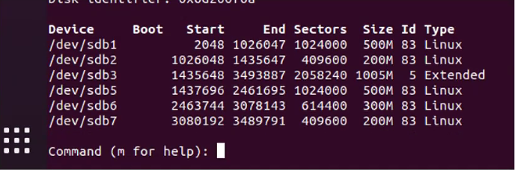

## **Changing Partition Types**

1. You will notice all the partitions are of type **Linux**. We want to change the **/dev/sdb7 Linux** partition to a **Linux Swap** partition. To change the partition to **Linux Swap** Partition press the **t** key then enter **7** to select the **7th partition**. When prompted for the **Hex** code, enter **82** and hit the enter key. **82** is the hex code for a **Linux Swap partition**. If you want to see the other codes available to you enter the **l** key when prompted for the hex code.
2. Press the **p** key to display the two primary partitions, the extended partition, and the three logical drive you just created. Record the output by taking a screenshot using the Windows Snipping tool and pasting it here:

**Snapshot here-2**

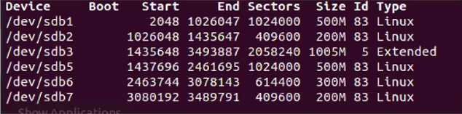

## **Questions to test your understanding (Red)**

|  |  |
| --- | --- |
| List all the primary partitions on the new 4GB drive | **/dev/sbdb1,/sdb2** |
| Name the extended partition if one exists on the new 4 GB drive | **/deb/sdb3** |
| List all logical drives if they exist on the new 4GB drive | **Sdb5/sdb6/sdb7** |
| Can you create additional primary partitions on the new 4GB drive? | Yes, or No, and Why?  Yes, max 4 partitions |
| Can you create additional logical drives on the new 4GB drive? | Yes or No and why?  **Yes you can have as many logical drives as possible.** |

## 

## **Deleting a Partition**

1. We will be deleting the **300MB** partition, To delete a partition, press the **d** key, you will be prompted for the partition **number** that you want to delete, press the **6** key, and hit the **enter** key as that is the partition that we wish to delete.
2. Press the **p** key to display the partition table. **Record** the output by taking a screenshot using the WindowsSnipping tool and pasting it here:

**Snapshot here-3**

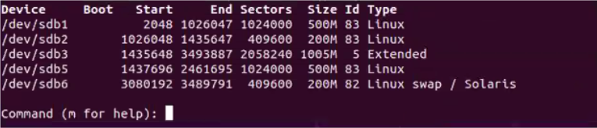

1. What do you notice in terms of the partition numbering?

When partition 6 was deleted, partition 7 took its place. Number 4 isn’t used.

1. **Save y**our work to the **hard disk** by pressing the **w** key, this writes the partition table information to the hard disk
2. Press the **q** key to quit fdisk program
3. You are now ready to call the lab instructor over to sign off on your lab.
4. type **exit** to get out of the **user root**.